Bay 8
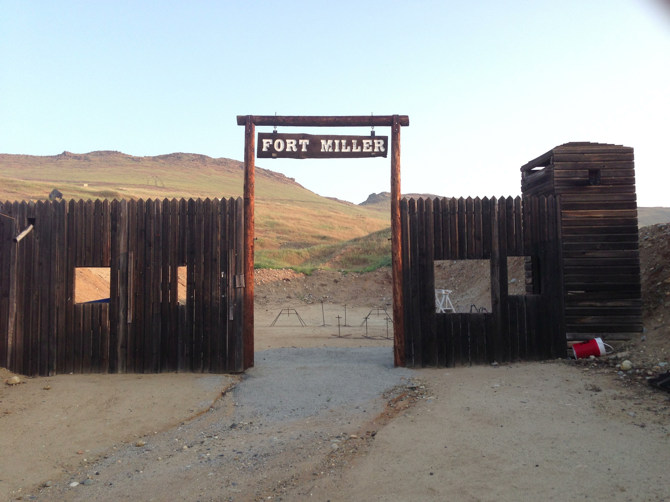

Pistol
Rifle
Shotgun

Start:

Shooter signals ready by saying “Ready Phrase”

ATB:

