Bay 1

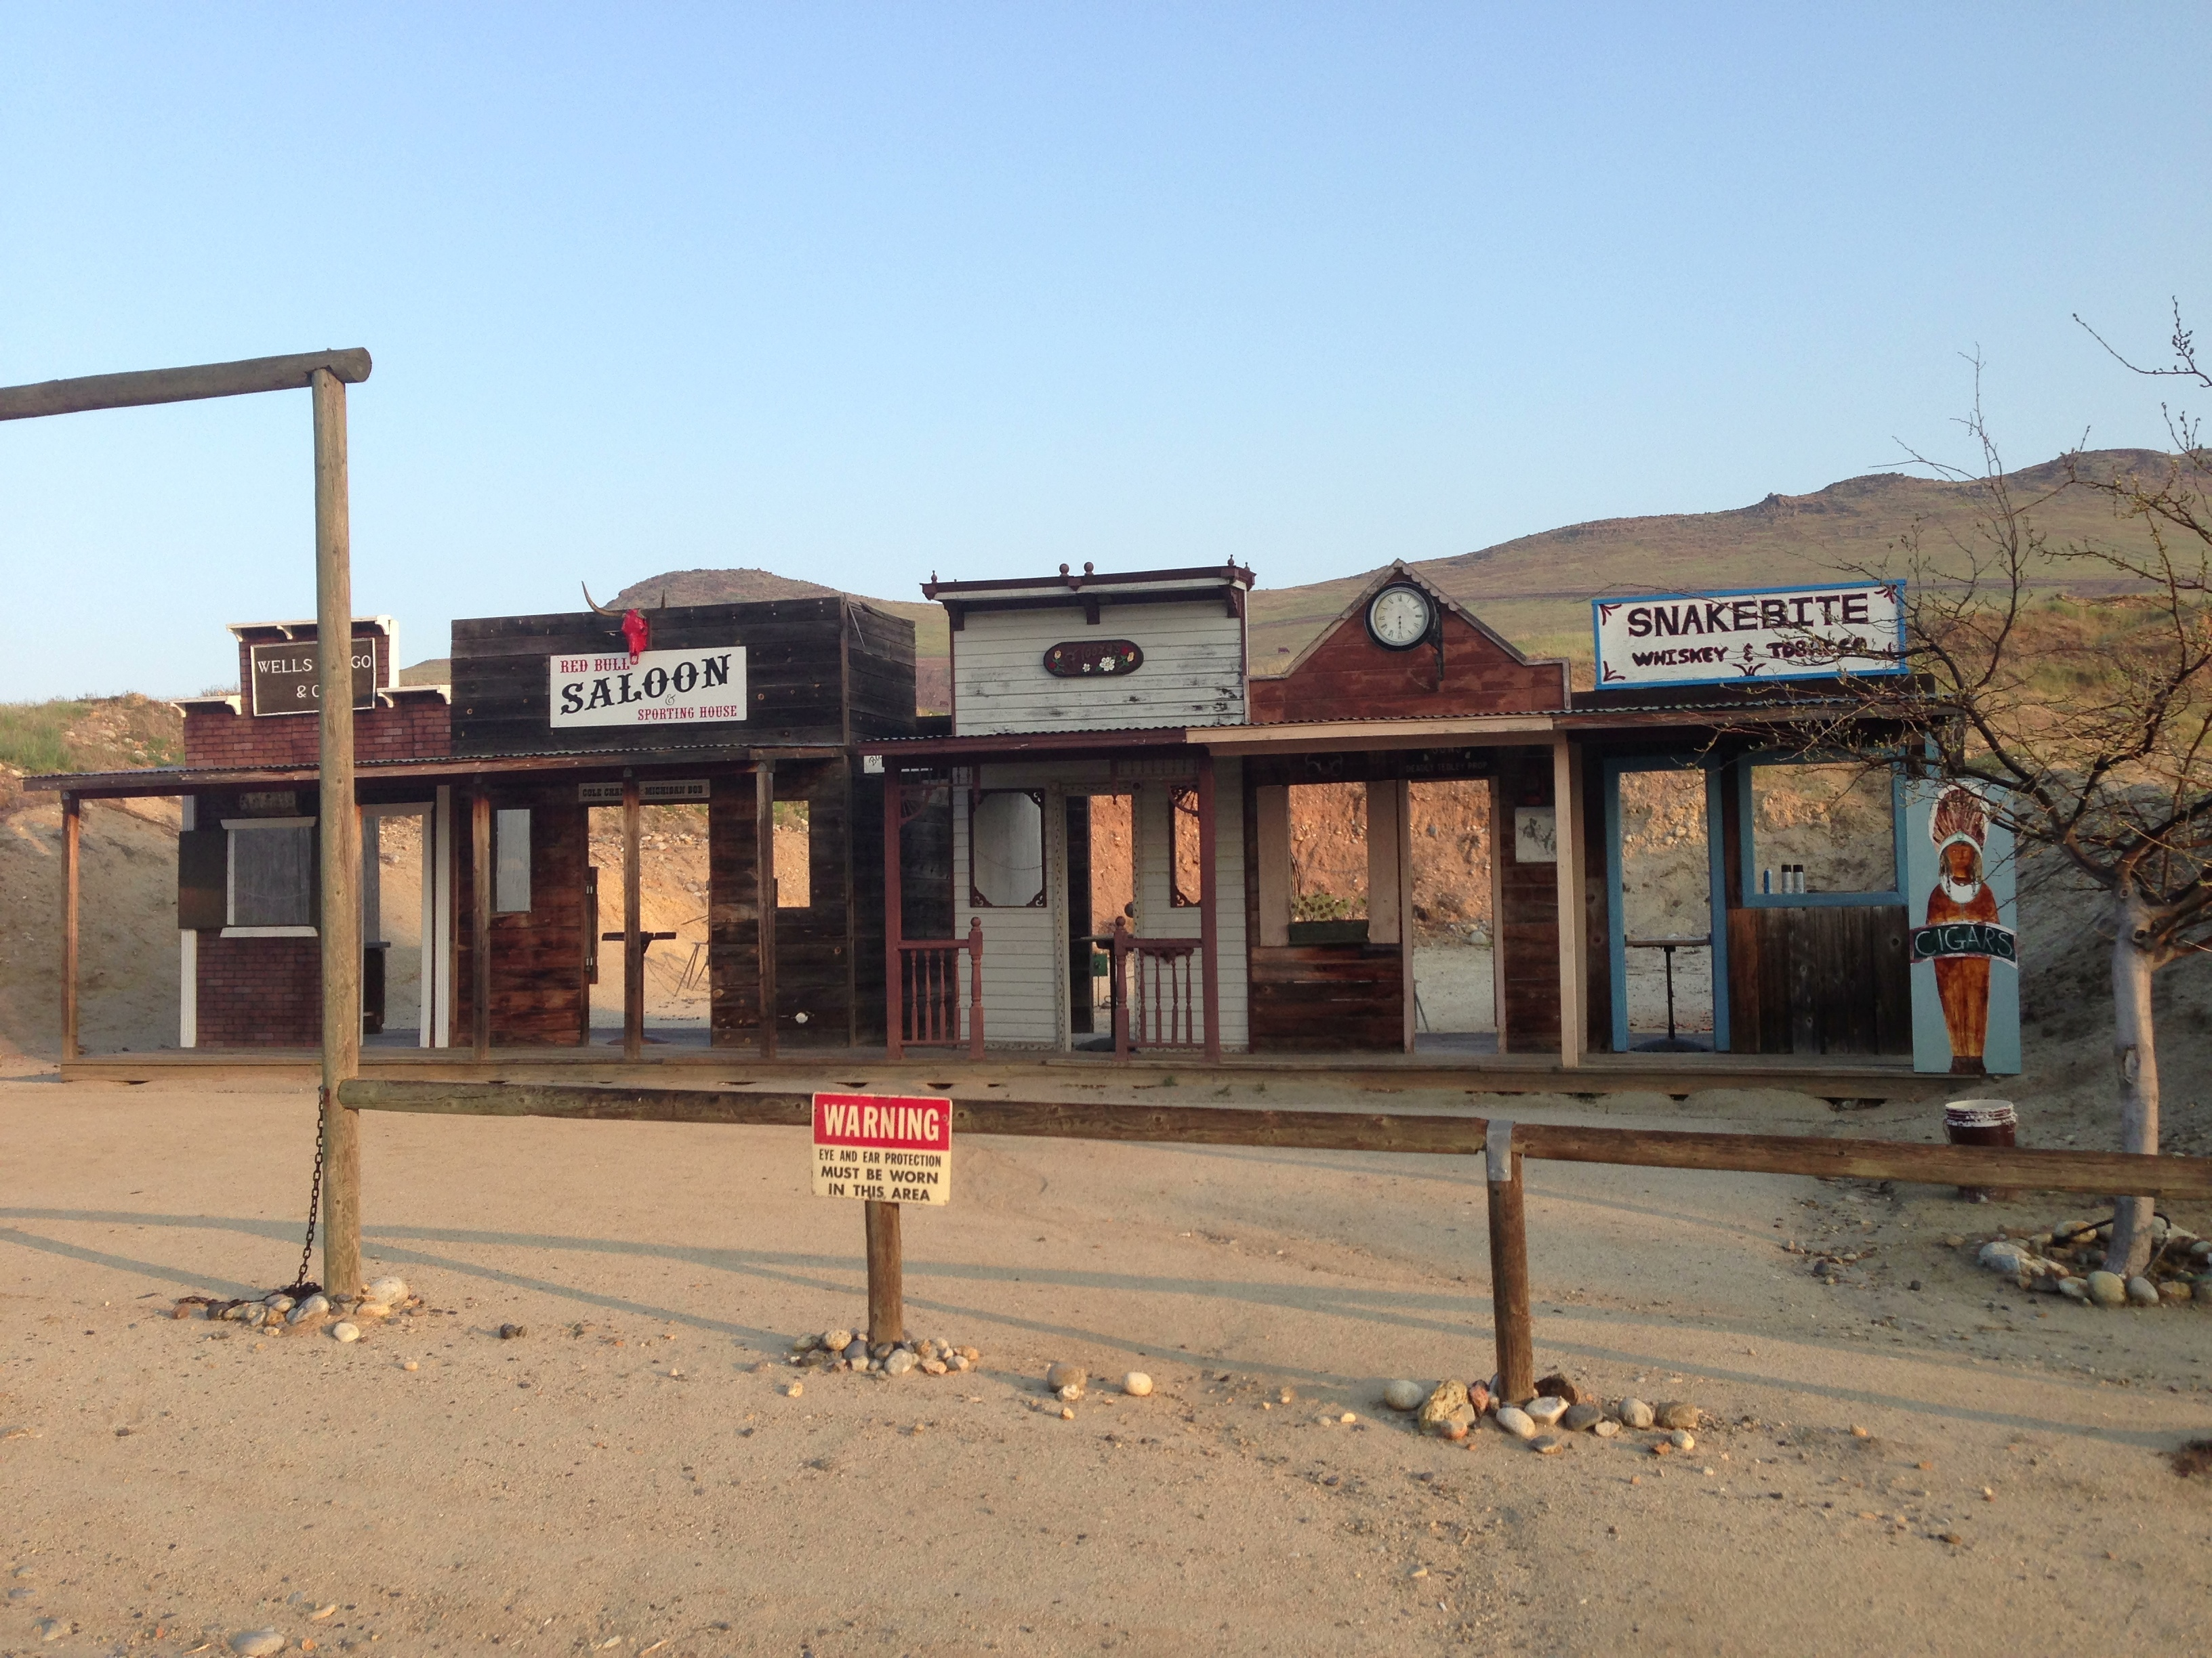
Pistol
Rifle
Shotgun

Wells Fargo Red Bull Saloon Floozy’s Ted’s Guns SnakeBite Whiskey

Alley

Start:

Shooter signals ready by saying “Ready Phrase”

ATB:

