Bay 4

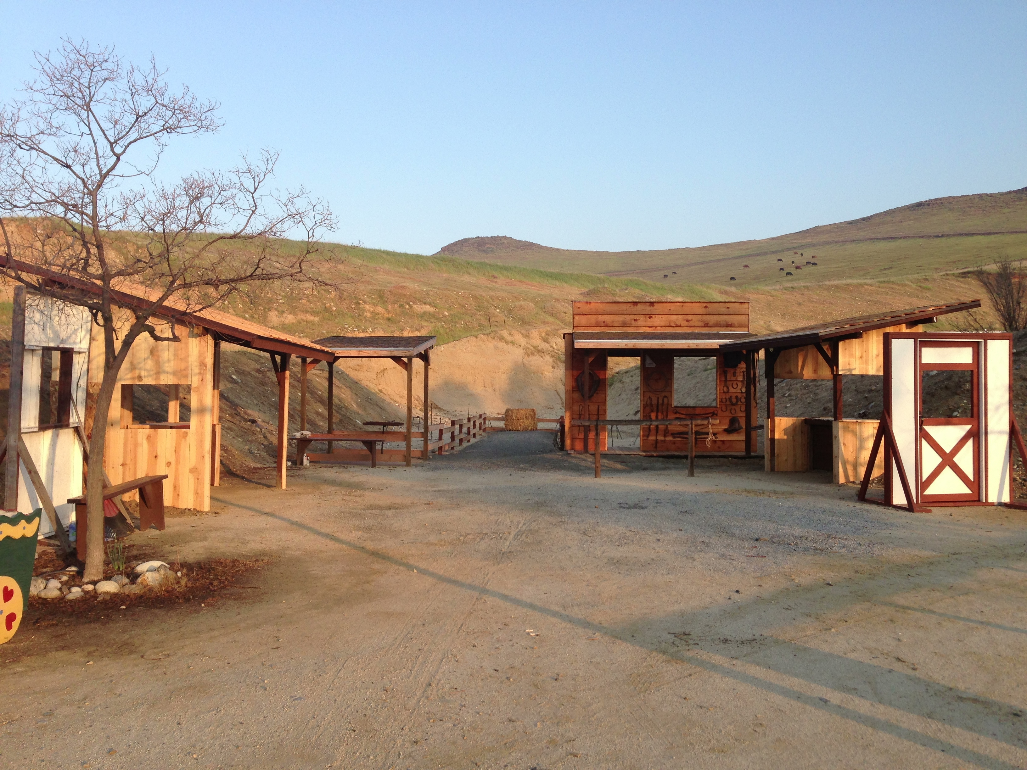
Pistol
Rifle
Shotgun

Hay Bales

Patio
Blacksmith Shop

Start:

Shooter signals ready by saying “Ready Phrase”

ATB:

