Bay 5

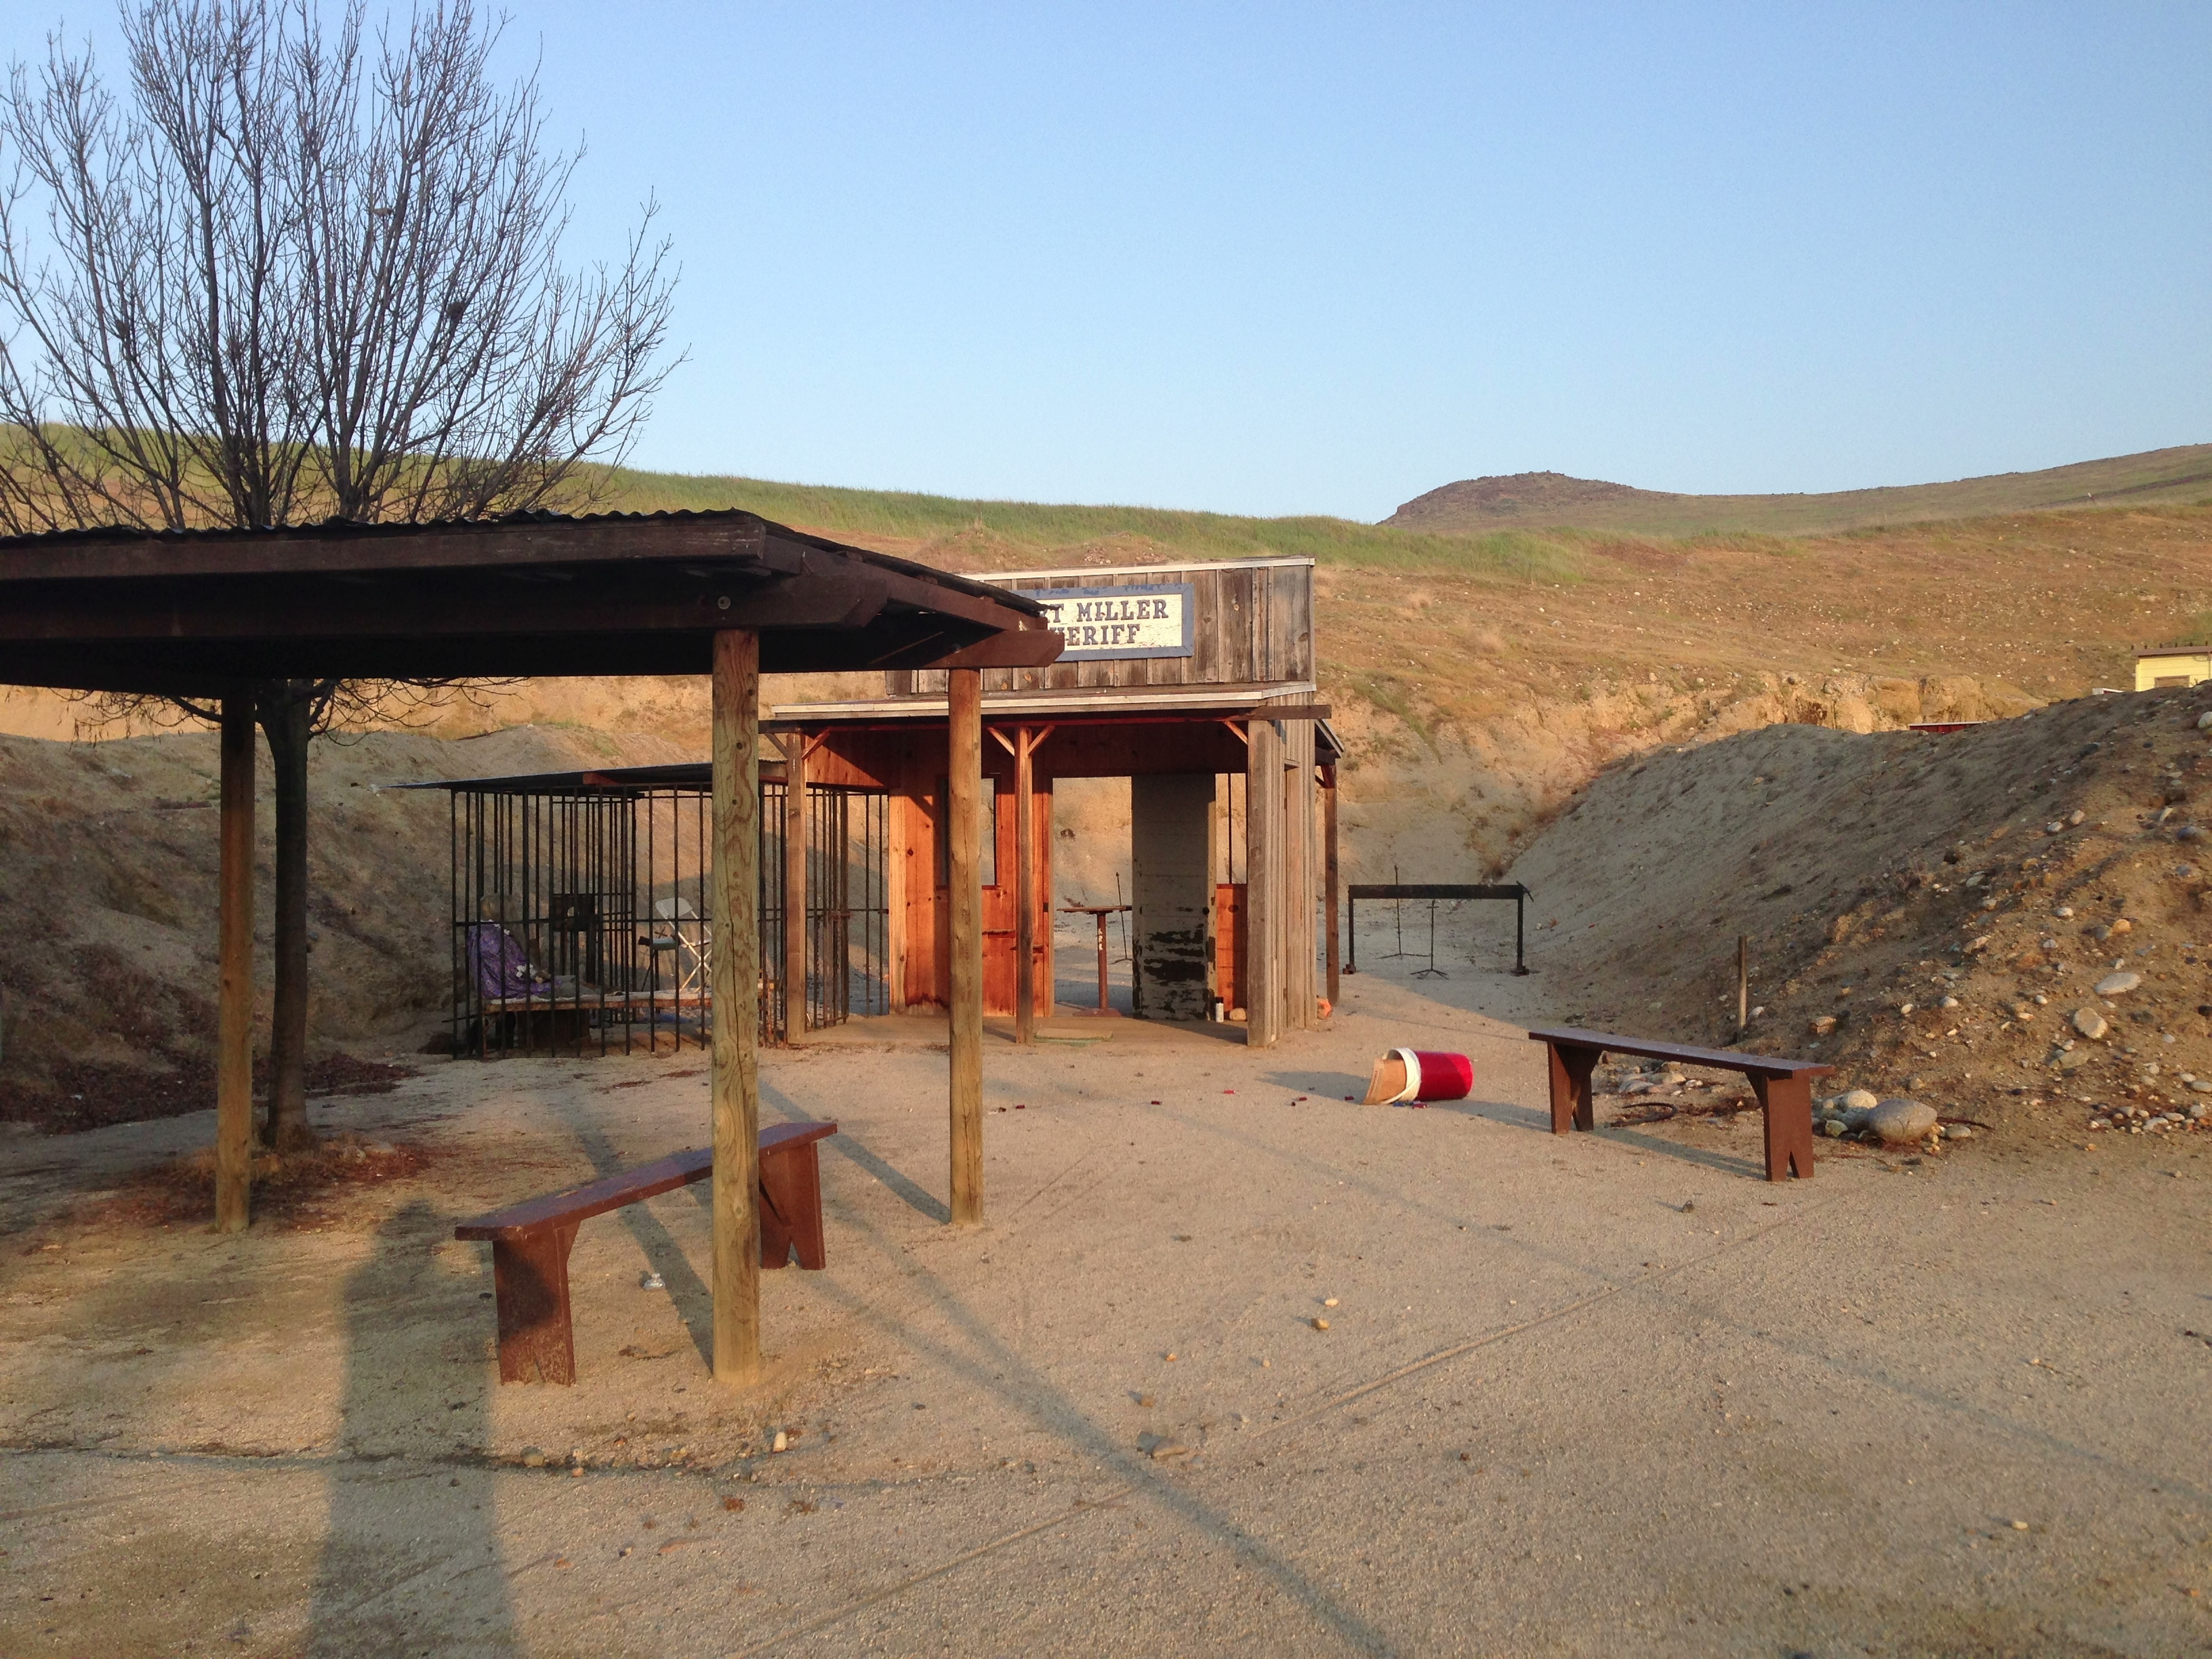
Pistol
Rifle
Shotgun

Fort Miller Jail

Start:

Shooter signals ready by saying “Ready Phrase”

ATB:

