Bay 6

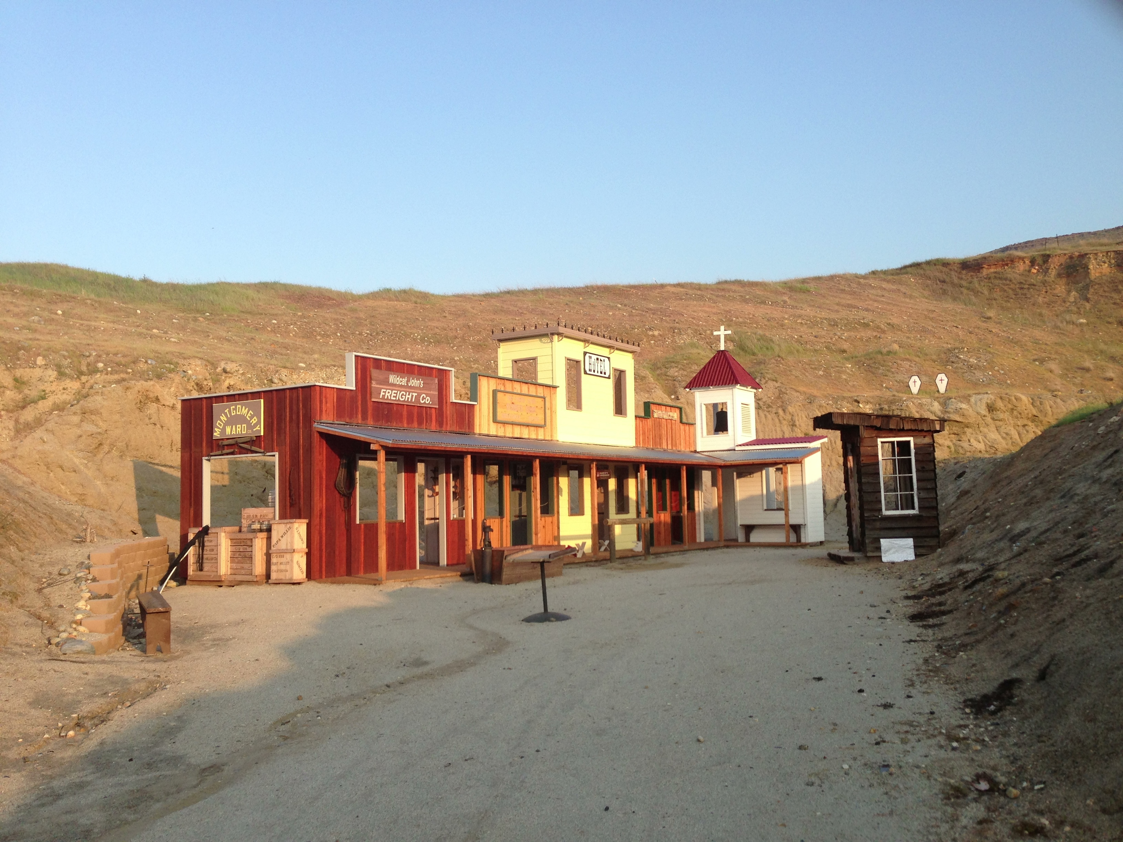
Pistol
W
D
W
D
W
D
W
W
D
W
D
W
W
Rifle
Shotgun
Bell
D
D
D
D
Door
Start:
Shooter signals ready by saying
“Ready Phrase”
ATB:

