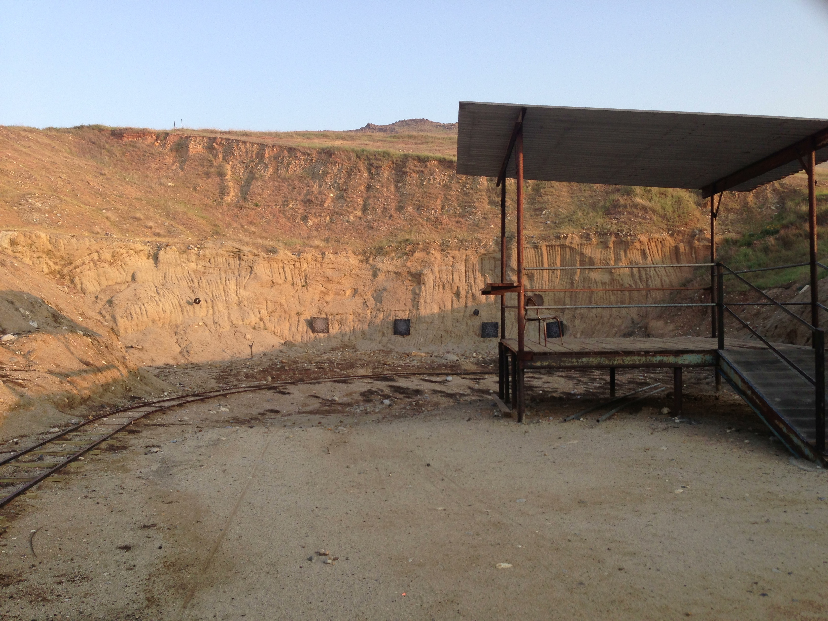
Bay 7

Hay Bale

Stage

Start:

Shooter signals ready by saying “Ready Phrase”

ATB:

