Bay 2

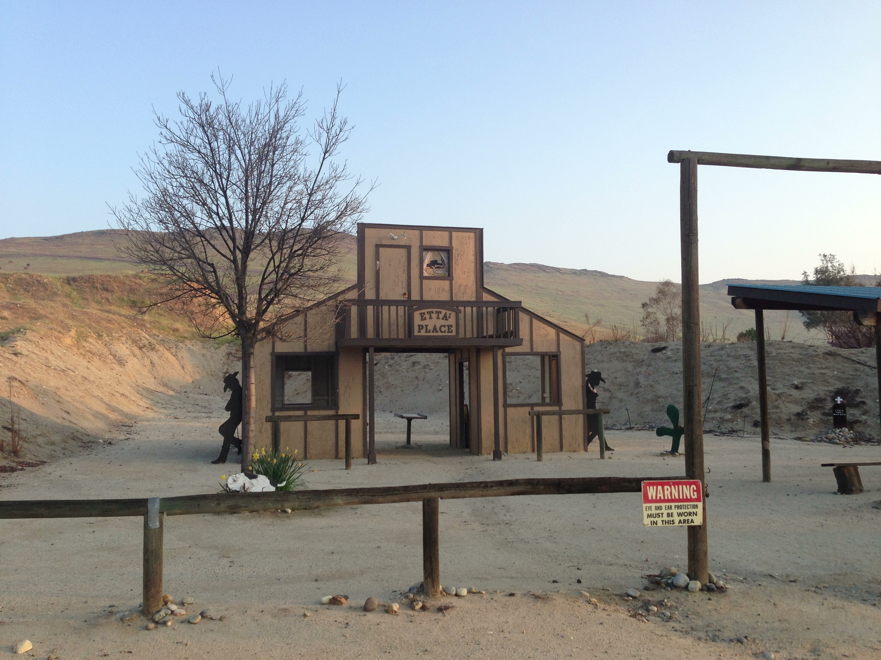
Pistol
Rifle
Shotgun

window open open
table

door door door door

ETTA'S PLACE

Hitching Rail Hitching Rail

Start:

Shooter signals ready by saying “Ready Phrase”

ATB:

